Balachandran, Ryan 2/3/2022
Course Number: PHYS.1410L
Section Number: 804
Instructor: Dr. Mittler
Partners(s): I don’t remember their names

Free-Fall Motion

Introduction

The purpose of this experiment is to study the motion of falling objects as they play a significant role in the history of science. An object which falls only due to the influence of a constant gravitational force is said to undergo free-fall motion. This motion will be examined in order to determine the acceleration due to gravity (g).

Theory

An object that is falling freely is acted upon only by a constant gravitational force exerted by the earth, and this force is directed towards the center of the earth. This constant gravitation force produces a constant acceleration due to gravity (g).

Acceleration is defined as the rate of change of velocity with respect to time:

$$1) a=\frac{v-v_{o}}{t} or v\left(t\right)=v_{o}+at$$

Where a = acceleration of the object, V_{o} = initial velocity, V = final velocity,
t = time interval

From equation (1), a plot of v vs t should be a straight line whose slope equals the acceleration, a.

Using the definition of average velocity (rate of change of displacement with time; it is the mean of initial and final velocity), one can fine the relationship between displacement (y) and time (t) (for constant acceleration):
$$2) y\left(t\right)= y_{o}+v_{o}t+\frac{1}{2}at^{2}$$

From equation (2), a plot of y vs t should be a parabola (for constant acceleration). Furthermore, the instantaneous velocity of the body at any instant during the motion can be determined by drawing a tangent to the displacement vs. time graph, at the corresponding instant of time. The slope of this tangent gives the instantaneous velocity.

Apparatus and Procedure

Materials:
- Ticker-tape timer
- Vernier Measuring Caliper
- Paper ticker-tape
- Meter Stick

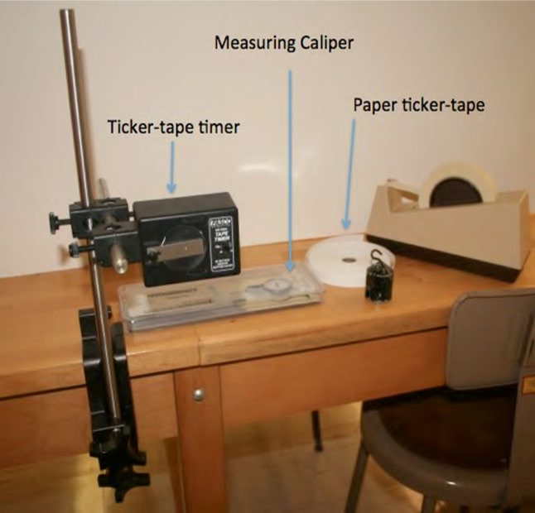
Ticker-tape timer, Measuring Caliper, and Paper ticker-tape

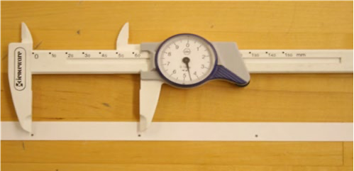
Vernier Caliper
Procedure

In this experiment an object will be allowed to fall vertically. The motion of the object will be determined by using the ticker-tape timer. The Paper-ticker-tape is attached to the mass which goes through the timer and as the mass falls, the timer will put marks on the tape at specified intervals of time. The measurements of the separation of these marks will allow one to determine the average velocity of the falling mass and thus enable us to analyze the motion. The Vernier Caliper will be used to precisely measure the distance between two tick-marks.

The measurement is made by holding the tape vertically at the end opposite from where the mass is and letting it go – thus the mass will fall straight down. Use the 40 Hz frequency setting on the Ticker-tape timer.

Results and Data

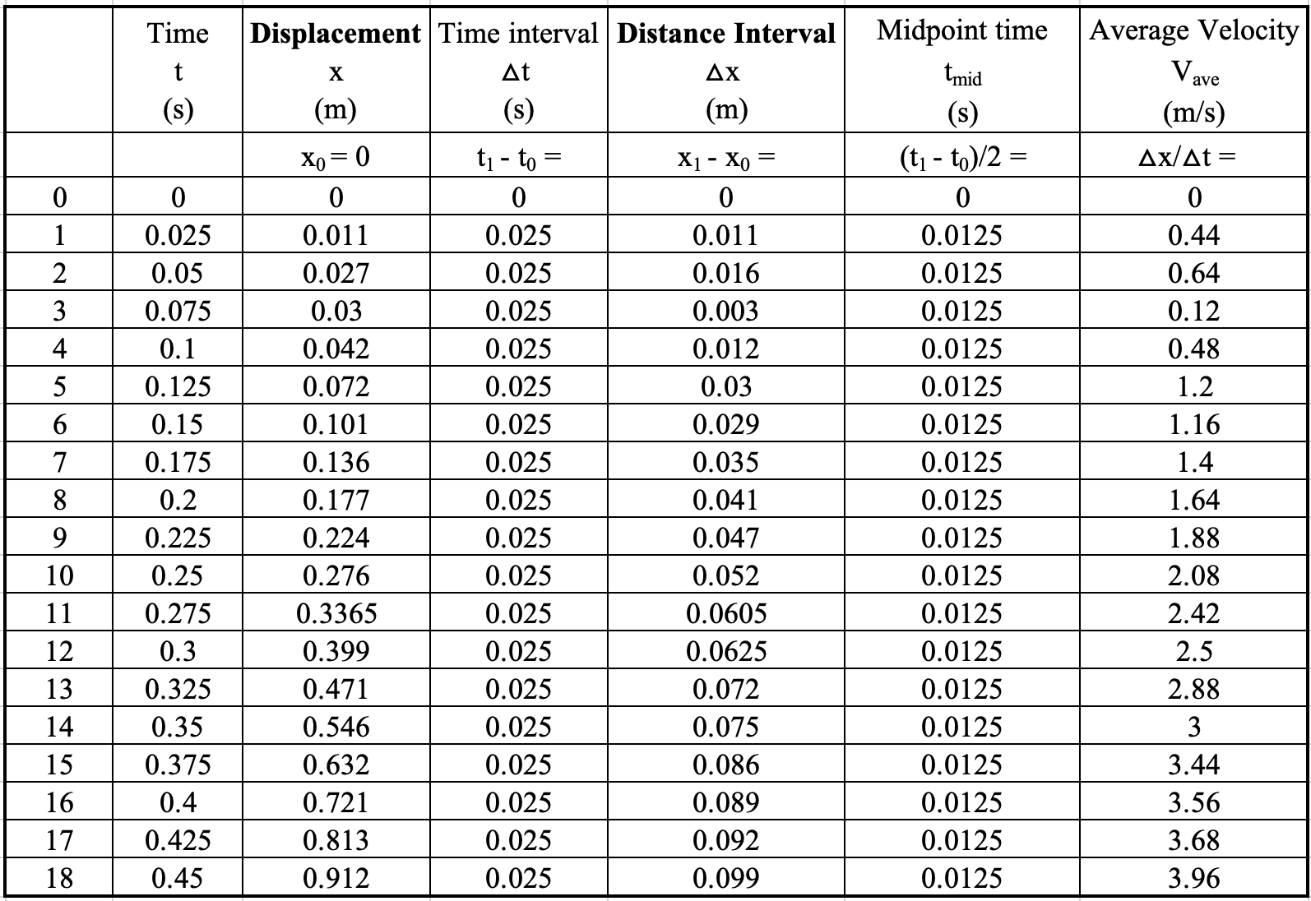

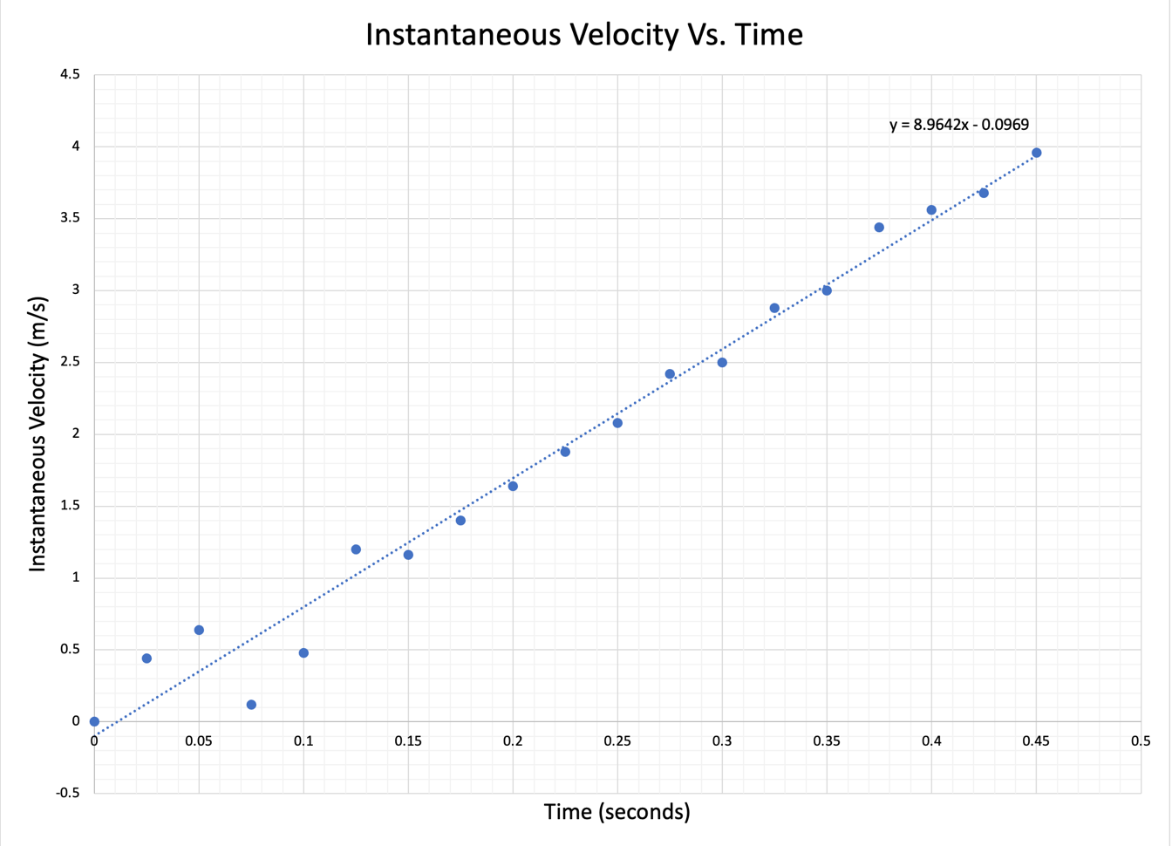

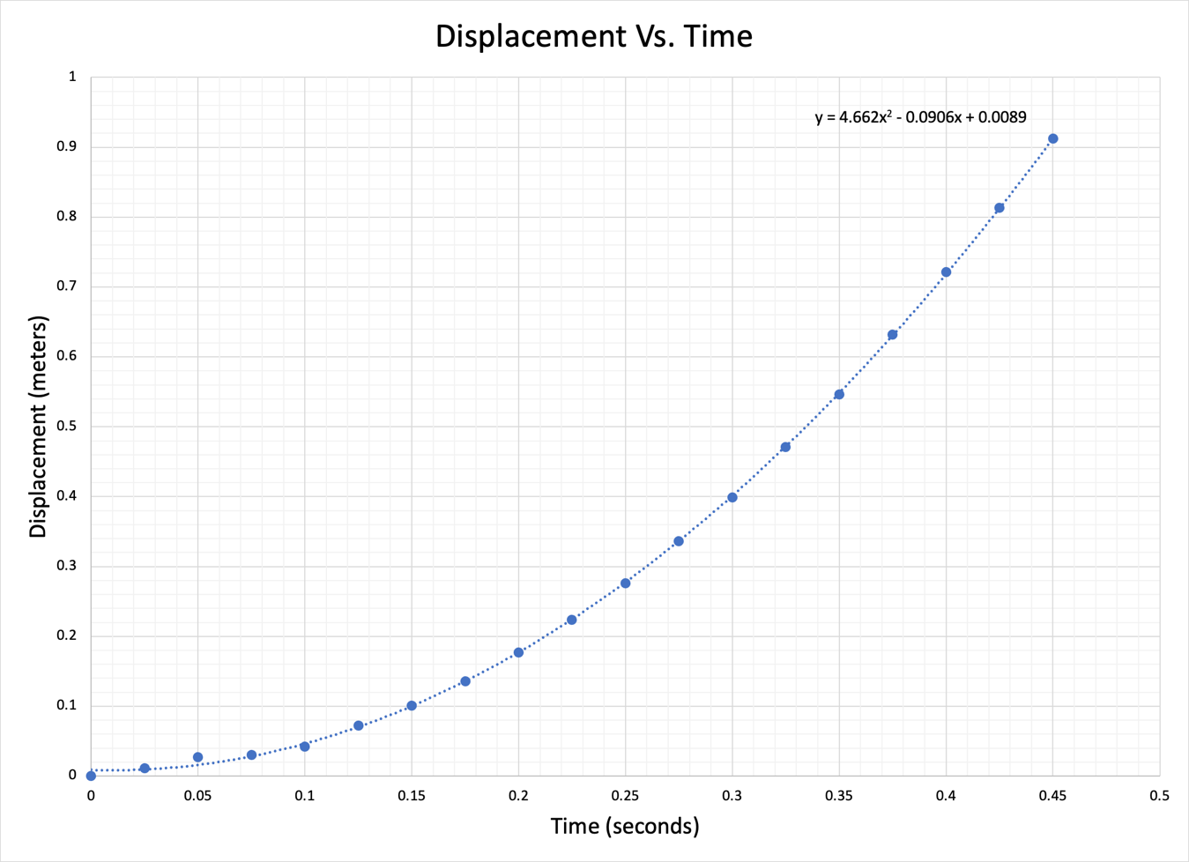
Analysis
Calculations:

Time intervals were in 0.025 second increments for a total of 0.45 seconds from releasing the weight to the weight hitting the ground.

The displacement of the weight was calculated by using a meter stick and measuring from the first mark on the paper ticker-tape, to the 18th mark.

The Vernier Caliper was used to measure the distance interval between two marks on the paper ticker-tape with more precision than the meter stick.

We could compare the accuracy of the meter stick (taken in cm then converted to meters) and the Caliper by subtracting X₁ from X₀, increasing the subscripts by one for each calculation.

Example:

Displacement X₀ = 0 meters
Displacement X₁ = 0.011 meters

Distance interval = X₁ – X₀ = 0.011 meters

Displacement X₁ = 0.011 meters
Displacement X₂ = 0.027 meters

Distance interval = X₂ – X₁ = 0.016 meters

The midpoint time was calculated by simply taking the time interval of 0.025 and dividing by 2 to obtain 0.0125 seconds.

Last, the average velocity was calculated by dividing the distance interval by the time interval:

$$V_{average(t=1)}=\frac{Δx}{Δt}=\frac{0.011}{0.025}=0.44 m/s$$

The time interval and midpoint time were the only constant variables in this experiment.

Discussion

For the first graph, since the velocity was linear (constant), then the instantaneous velocity is linear as well at the midpoint of the time interval. The starting graph points are abnormal due to the difficulty of reading the tick marks on the paper ticker-tape and telling what was a mark and what wasn’t. After the first 5 data points, the marks became much easier to distinguish.

The parameters of the motion of the object that are determined by the slope of the graph and the intercept is the acceleration of the object towards the ground due to gravity. When the object is released, it is in free-fall as no other forces are acting on it besides gravity, therefore it accelerates at a constant speed of $9.8{m/s}^{2}$ .

Taking the last data point of time and velocity: (0.45 seconds and $3.96 {m/s}^{2}$), I input the final time into the intercept of $y=8.9642x-0.0969$ to compare how close the result is to the expected velocity.

$$y=8.9742\left(0.45\right)-0.0969=4.03389-0.0969=3.93699 {m/s}^{2}$$

For the Displacement vs. time graph, the trendline followed the data points much better than the instantaneous velocity and time graph. It can be clearly seen that at the very start of the experiment, the weight started from an initial point and began to accelerate, increasing its displacement rapidly before hitting the ground. The curve of the graph shows the increase in its distance between each data point as well as the instance in time as it is affected by gravity. The relationship between displacement and time can be described as the initial displacement plus the initial velocity times time, added to half the acceleration multiplied by time squared, or:

$$y\left(t\right)= y_{0}+v_{o}t+\frac{1}{2}at^{2}$$

Lastly, when comparing the two graphs of Instantaneous velocity vs time and Displacement vs time, we can get the average velocity from the slope of the displacement graph, or the change in displacement over the change in time. To get the instantaneous velocity, we pick a point on the Displacement graph and draw a tangent at that instance of time to find the slope of that position.

Conclusion

Overall, the goal of the experiment was to study the motion of falling objects under the influence of gravity and examine the motion to determine the acceleration due to gravity. The results of the experiment corresponded somewhat well to the theory stated earlier and the graphs depicted accurate representations of Displacement vs Time and Instantaneous velocity vs Time for an object in free-fall. The only errors we encountered were being able to get precise measurements on the first five or so data points on the instantaneous velocity graph as it was difficult to tell what was a proper mark on the paper ticker-tape or if it was smudge or dust.

Questions

- Explain what differences you would observe in your data if you started the experiment by launching the object vertically upward rather than just letting it fall from rest.

  - The first difference would be from the Displacement graph. Instead of a curve, it would be a parabola (looking like an N). Given you were able to throw the object vertically upward into the air from a standstill, the Displacement graph would see a near instant rise before gravity slows the object and the displacement quickly decreases before increasing again when it passes its initial starting point. The Displacement graph would change from a curve to a parabola because of how the Displacement is calculated from its initial position. I think of it like taking a retractable rope that is always taut with one end pinned at the initial position as it measures my distance from where I started. Should I change direction or head back to where I began, my displacement would be determined by where I am on the parameter of a circle centered around the initial point.

The second difference would be the instantaneous velocity graph since the Displacement graph changed. When the object is thrown up, the instantaneous velocity will start at the speed at which it was tossed before going down at a constant velocity. When the Displacement hits zero and begins the rise, the instantaneous velocity will change and rise at a constant rate in the positive direction. So when the object is rising, the instantaneous velocity will be going down at a constant rate before increasing at a constant positive rate when the object falls past its initial position.

- What are the most significant conditions in the experiment that limited your ability to observe the ideal free-fall motion?

  - The most significant condition in the experiment that limited our ability to observe the ideal free-fall motion was being able to track the recorded marks on the paper ticker-tape. As the object is released and its acceleration increased, there were a lot of marks in a very short amount of time at the beginning of the paper ticker-tape. Whether it was because the Ticker-tape timer wasn’t able to properly mark the position on the paper-ticker tape or we weren’t able to distinguish whether it was a mark or a random dot on the paper, the beginning of our instantaneous velocity graph was rather non-linear and inconsistent.

- Describe what you would predict the results of the experiment would be if the entire apparatus was under the water.

  - If the apparatus was under the water, then the Displacement would be linear because the object would float down at a constant velocity regardless of gravity. The heavier the object, the faster it would sink, but the Displacement would remain linear, and the velocity would be a constantly positive.

